 | UTM – FC DIGITAL FORENSIC  UNIVERSITI TEKNOLOGI MALAYSIA
DIGITAL FORENSIC
(MECR1033)

LAB 3
Investigate Computer Logon/Logoff with
“TurnedOnTimesView” Software

STUDENT NAME : KEERTENNAH DEVI A/P PONNAMBALAM
LECTURER NAME : ASSOC.PROF.TS.DR. SITI HAJAR OTHMAN
MATRICS NO. : MEC254026
SESSION : 2025/2026-1
SECTION : 52
Instruction: Complete all the following practices.

SECTION A: Install TurnedOnTimesView software

- TurnedOnTimesView is a tool is a freeware tool that analyzes the event log of Windows operating system and detects the time ranges that your computer was turned on.

- TurnedOnTimesView allows you to get this information from your local computer, and a remote computer on your network if you have enough privilege to read the event log of Windows remotely.

SECTION B: Observe what you can see

- Explain what field you can see after you manage to open the tools?
After opening TurnedOnTimesView, several fields are displayed that provide information about the computer’s power activity. The main fields include as mentioned below,
- Startup time shows the exact date and time when the computer was powered on.
- Shutdown time indicates when the computer was shut down.
- Last system event displays the last recorded system activity before shutdown.
- Duration shows how long the computer remained turned on.
- Shutdown reason explains why the system was shut down, such as system failure or user action.
- Shutdown type indicates whether the shutdown was normal or unexpected.
- Shutdown process shows how the shutdown process occurred.
- Shutdown code displays the hexadecimal code related to the shutdown event.
- Computer name identifies the name of the computer where the logs were collected.
- How many items appears?
A total of 287 items appears in the TurnedOnTimesView log list.

- What is the Computer Name?
The computer name displayed in the tool is DUNE.

- What is the Code for Shut down?
The shutdown code recorded in the log is 0x000500ff.

SECTION C: Investigate the meta information of the tools GUI

- Capture/snapshot the first 6 logs from the first Startup Time the tool captured.
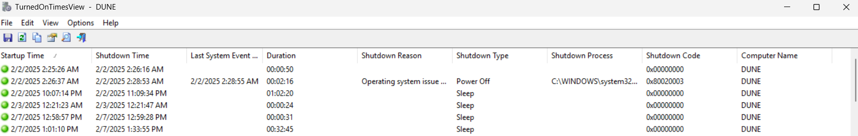

- Is there any shutdown reason that appears in the list? Due to what reason the shutdown happens?
Yes, shutdown reasons are displayed in the list. One reason the computer shuts down is because of System Failure. This means the computer had to shut down because something went wrong with the system like the computer crashed or a hardware part stopped working or a big problem happened with some software. The computer usually shuts down by itself. The operating system writes it down automatically. The user does not normally tell the computer to shut down when this happens. System failure is a problem that makes the computer shut down.

- How to mark odd or even rows? Can you snap and show the result of 20 rows being marked?
To mark odd or even rows in TurnedOnTimesView, the user can enable the “Mark Odd/Even Rows” option from the View menu. Once enabled, the rows are alternately highlighted, making it easier to tell the log entries apart. A snapshot of the first 20 marked rows was captured to clearly show the alternating row colours, which improves readability and log analysis.
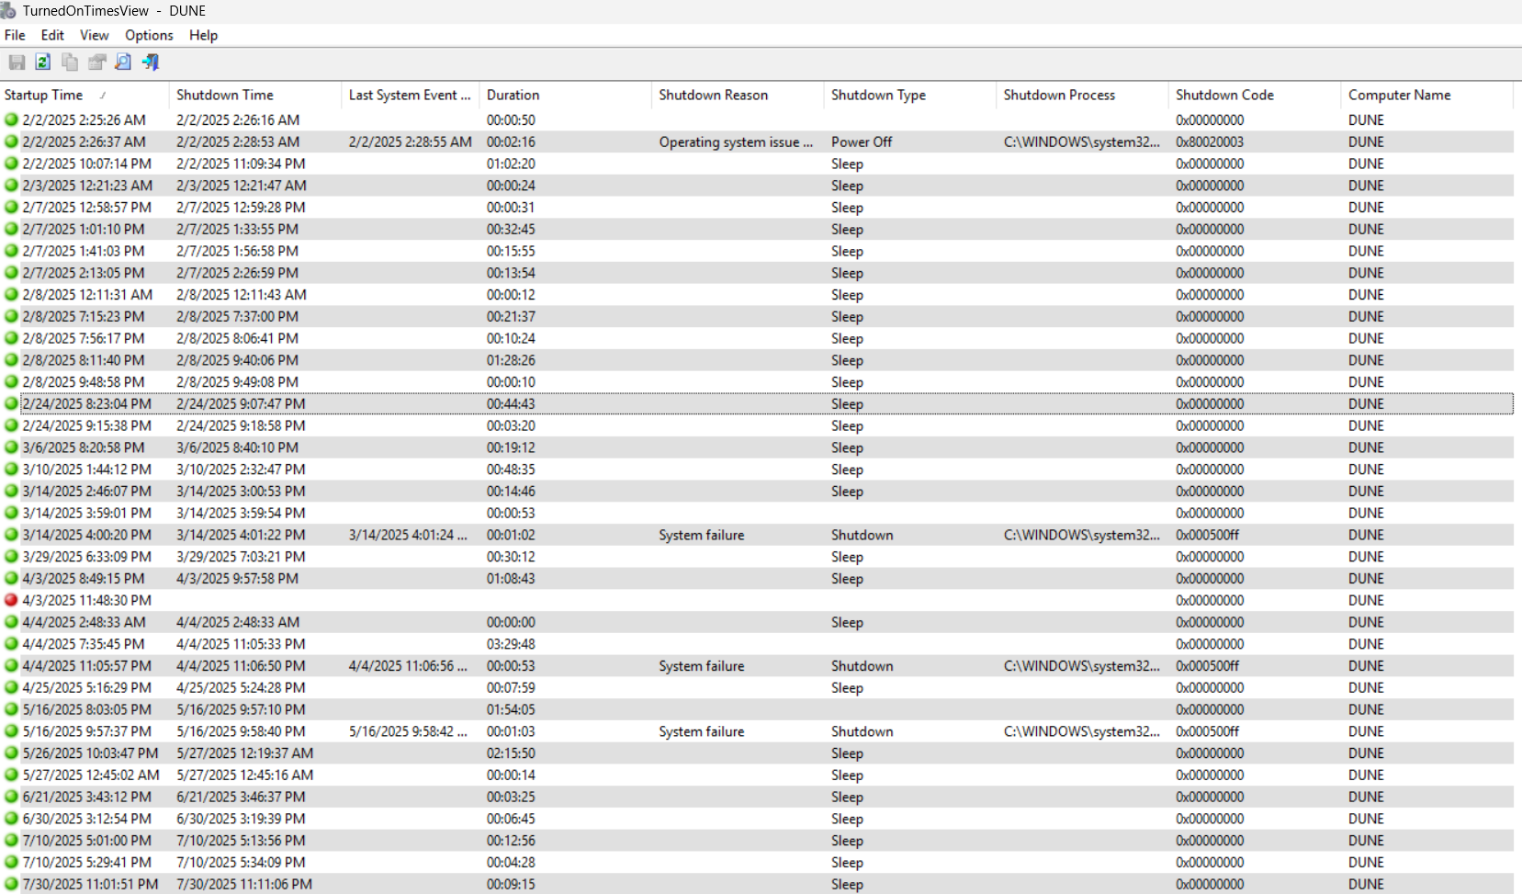

- In your opinion, why do investigators need to understand the off and on status of the computer?
In my opinion, understanding if a computer is on or off is important for investigators. This is because it helps them figure out when the computer was being used. When investigators look at when a computer was started up and shut down, they can tell if it was on during a time when something bad might have happened. This information can help prove or disprove what a user says happened. It can also show if someone got into the computer who should not have. The computer activity can be linked to digital clues. Computer startup and shutdown times can also help investigators identify if a computer was shut down in a way, which might mean someone was trying to tamper or malicious activity.

- Are there any similar tools that can perform the same process such as the TurnedOnTimesView? List down the tools.
Yes, there are several other tools that can perform similar functions to TurnedOnTimesView, including
  - The Event Viewer on Windows is a tool that lets you look at what happens when the Windows system starts up and shuts down. You can use the Event Viewer to see what is going on with the Windows system when it starts and stops. The Event Viewer is useful, for checking the Windows system startup and shutdown events manually.
  - The LastActivityView is a tool that shows you what the users and the system have been doing over time. It is, like a timeline that lists all the activities of the users and the system. The LastActivityView helps you see what has been going on with the users and the system.
  - Windows Reliability Monitor shows system stability and shutdown or crash history.
  - The tool LogonSessions from Sysinternals shows you all the logon sessions. It also gives you some related details about these LogonSessions. This is useful when you want to know more, about the LogonSessions on your system.
  - FTK Imager can extract system event logs for further forensic analysis.

END_OF_LAB3
Marks:

